Response to the Reviewers’ Comments for TIA-2026-IPCC-0540
Manuscript Title: Design and Implementation of a Non-coupled Integrated Transformer for a Two-phase Interleaved Flyback PFC Rectifier

Aug xx, 2026
Dear Editor,
We would like to express our sincere appreciation to the reviewers for their constructive and insightful comments on our manuscript. The manuscript was revised in accordance with point-by-point answers to all the questions and suggestions.
- Pages x to x correspond to Reviewer #1’s comments.
- Pages x to x correspond to Reviewer #2’s comments.
- Pages x to x correspond to Reviewer #3’s comments.
We conducted additional simulations and experiments and revised the manuscript accordingly. In particular, we strengthened the literature review, clarified the new contributions beyond the conference version, and added additional frequency-domain characterization and thermal evaluation. We also updated the manuscript to improve clarity, consistency, and figure/table referencing based on the reviewers’ suggestions.
We hope the manuscript is now acceptable for publication.

Best Regards,
Sihoon Choi
Corresponding author,
Institute of Materials and Systems for Sustainability, Nagoya University
Email: choi.sihoon.w4@f.mail.nagoya-u.ac.jp

To Reviewer 1
We authors appreciate your valuable comments. The revised parts are indicated by red texts in the manuscript.

Comments to the Author
The manuscript presents a study of an interleaved flyback topology that employs a single transformer shared between the phases. The proposed approach is interesting, and the presented results demonstrate a reduction in magnetic component size compared to conventional solutions. However, several important technical aspects are not adequately addressed, making it difficult to assess the technique's actual superiority and practical benefits. Although a standard EE core is employed, the windings are distributed across all three legs of the magnetic core. This arrangement may complicate large-scale manufacturing, increasing production costs and assembly complexity. Furthermore, important technical aspects, such as the impact on leakage inductance, are not discussed and require further clarification. The following comments are provided to improve the manuscript:
1) Leakage inductance is a critical issue in flyback converters, significantly affecting efficiency, power density, voltage stress, and overall converter performance. Due to the proposed winding arrangement, in which the primary and secondary windings do not appear to be fully overlapped, leakage flux may increase compared to conventional transformer designs. A detailed study quantifying the impact of the proposed winding configuration on leakage inductance is necessary for a proper evaluation of the proposed solution.
Thank you for your comments. We agree, and we wanted to reduce leakage inductance from the two transformers as much as possible to avoid the problems mentioned. In reality, when winding this transformer, the windings are overlapped with each other to reduce leakage as much as possible. Moreover, this overlapping resulted in a coupling coefficient of 0.970 for transformer $N_{12}-N_{34}$ and 0.979 for transformer $N_{56}-N_{78}$. We anticipate that these values can be further improved when utilizing automated, industrial-grade manufacturing techniques.

The figures shown about the transformer prototype, Fig. 10(b), is a representation of the general winding structure. This was so that the location of each winding can be easily pinpointed. We apologize if this graphical simplification gave the impression that the windings were not physically overlapped in the actual prototype. We have clarified this in Section V of the manuscript as follows.

Before revision | After revision
(Section V-A, 1st paragraph)  The prototype two-phase interleaved flyback rectifier, shown in Fig. 10(a) operating in DCM was built to verify the operation of the integrated transformer. The prototype integrated transformer, shown in Fig. 10(b), was also designed using the proposed method…. | (Section V-A, 1st paragraph)  The prototype two-phase interleaved flyback rectifier, shown in Fig. 10(a) operating in DCM was built to verify the operation of the integrated transformer. The prototype integrated transformer, shown in Fig. 10(b), was also designed using the proposed method. To strictly minimize leakage inductance, the primary and secondary windings of the transformer for each respective phase were physically overlapped on their designated legs….

2) No efficiency measurements are presented in the manuscript. Efficiency is a key performance indicator and is essential for assessing the effectiveness of the proposed topology. Experimental efficiency results over a range of output power levels should be included.
We sincerely thank the reviewer for pointing this out. We agree that efficiency is a fundamental performance metric for evaluating the proposed topology. We have experimentally measured the efficiency of the converter over its entire operating range, up to an input power of 250 W using a Hioki PW8001 Power Analyzer. The resulting efficiency curve, shown in the figure below, has been added to the revised manuscript as a new figure Fig. 16. The efficiency peaks approximately 84.6% near full load in two-phase drive, and is discussed in the newly added Section V-C.

Before revision | After revision
N/A | C. System-level Efficiency of the Proposed Interleaved Flyback Rectifier with the Integrated Transformer  To evaluate the overall performance of the proposed topology, the system-level efficiency of the prototype converter was measured over a wide operating range up to an input power of 250 W. The input and output power measurements were recorded utilizing a Hioki PW8001 Power Analyzer. Fig. xx illustrates the measured efficiency curve during two-phase interleaved operation. As shown, the converter achieves a peak efficiency of approximately 84.6% near full load.    Fig. 16. Efficiency curve of the proposed interleaved flyback rectifier with the integrated transformer, up to full-load operation of 240 W.

3) A comprehensive comparison with a conventional interleaved flyback solution is needed. Key performance indicators such as magnetic volume, efficiency, power losses, current ripple, and THD should be compared to substantiate the claimed advantages of the proposed approach.
We thank the reviewer for this valuable insight. Because the primary contribution of this paper is the introduction of a novel integrated magnetic structure, our analysis focuses heavily on the volumetric reduction of the magnetic components and the verification of independent phase operation without magnetic interference. Furthermore, because of the strict structural decoupling achieved, the converter can reliably operate with a single-phase drive under light-load conditions, allowing for a contribution towards improving light load efficiency with higher power density. Given that the primary scope of this research is the physical verification of this magnetic decoupling and the validation of the integrated core structure, we believe the current experimental prototype rigorously demonstrates the proposed concept.

We then address your concerns as follows. Because the fundamental (DCM) operation of the proposed flyback rectifier with an integrated transformer remains electrically identical to that of a conventional interleaved flyback converter with discrete transformers, key electrical parameters such as current ripple and THD are theoretically unaffected by the shared core structure. Each point of interest is further explained below:

- Magnetic Volume: As detailed in Section IV, our volume analysis using the area product (AP) method demonstrates that the proposed integrated transformer achieves an estimated 56% volume reduction from 21106.38 mm³ to 9398.46 mm³, compared to its conventional discrete counterpart as a result of an analytical comparison detailed in Table III. The proposed design has therefore a volume advantage.
- Efficiency and Power Losses: Regarding the overall efficiency and power losses, the proposed integrated topology achieves a peak experimental efficiency of 84.6% near full load. Because the proposed topology operates identically to a conventional interleaved flyback PFC rectifier with discrete transformers, and the two transformers have been successfully decoupled with $k≈0.0005$, the semiconductor and switching losses are expected to be nearly identical to those of a discrete baseline. Consequently, the primary distinction in power dissipation between the proposed and conventional topologies lies strictly within the magnetic components. This is further explored in Comment #6.
- Current Ripple: Because the converter preserves identical DCM operation per phase, utilizing the same fixed switching frequency $f_{s}$, duty cycle $D$, and magnetizing inductance $L_{m}$ as a conventional setup, the phase currents are governed by the exact same electrical principles. Consequently, the input and output current ripples are fundamentally identical to a topology with discrete transformers, and the standard ripple cancellation benefits of two-phase interleaving are fully preserved.
- THD (Total Harmonic Distortion): Natural Power Factor Correction (PFC) is achieved via standard DCM operation, where the average input current inherently tracks the sinusoidal envelope of the AC mains. Because our structural decoupling guarantees that no cross-phase magnetic interference or transient disturbances occur, the integrated core does not distort the independent phase currents. Therefore, the THD performance is completely preserved and remains equivalent to that of a conventional interleaved flyback rectifier with discrete transformers.

4) Experimental load transient results should be provided to demonstrate the dynamic performance of the converter and to verify the claimed decoupling between phases under transient operating conditions.

We sincerely thank the reviewer for this valuable suggestion. We completely agree that verifying the decoupling between phases under transient operating conditions is a critical concern to ensure the reliability and stability of the integrated magnetic structure. While experimental load transient tests were beyond the immediate scope of our current prototype verification, the primary contribution of our work is the fundamental structural decoupling of the magnetic flux paths within a single shared EE-core.

To directly address the concern regarding dynamic states, it is essential to highlight the decoupling mechanism of the proposed structure: the decoupling is geometrically enforced by dividing the transformer $N_{12}-N_{34}$ turns symmetrically across the two outer legs and intentionally winding them with opposite polarities. This specific arrangement creates strictly orthogonal flux paths, causing flux cancellation in the center leg during its operation. Therefore, the flux generated by $N_{12}-N_{34}$ circulates exclusively between the outer legs, while the flux from $N_{56}-N_{78}$ on the center leg splits evenly and returns through the outer legs without inducing a net voltage in windings of $N_{12}-N_{34}$.

Because this magnetic isolation relies on the winding geometry rather than steady-state electrical parameters, we expect that the structural decoupling inherently holds true even under load transients. We have successfully verified this lack of magnetic interference between the two transformers in our experimental prototype up to 240 W, achieving a negligible inter-phase coupling coefficient of $k≈0.0005$.

Furthermore, because the proposed two-phase integrated topology preserves the fundamental control and operational principles of a conventional discrete interleaved flyback rectifier, the overall dynamic performance is expected to remain largely unchanged from a standard, discrete implementation.

5) A photograph of the experimental prototype, including identification of the main components, should be included. This information is important for evaluating the practical implementation, overall size, and power density of the proposed converter.
Thank you for your comments. We have added a photograph of the experimental prototype to the revised manuscript to provide a better perspective on the implementation, footprint, and power density. The primary and secondary side of the converter are separated for easier experimental verification.

Because the hand-wound nature of the custom integrated transformer makes it challenging to visually distinguish the individual windings from the photo alone, we have also included an accompanying structural diagram (Fig. 13b). This diagram clearly identifies the main components and winding locations.
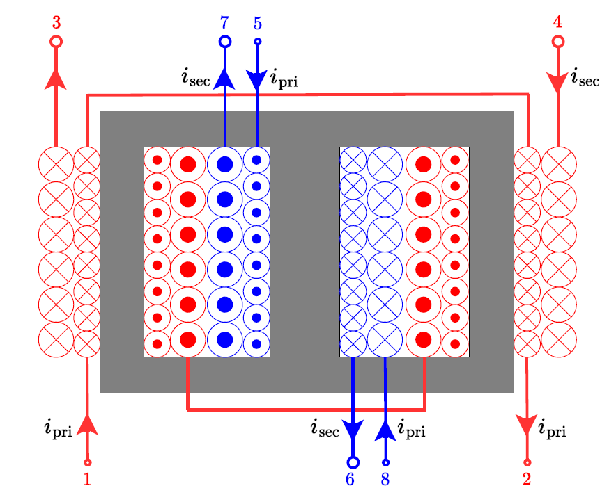

6) A detailed loss breakdown should be presented, particularly for the transformer, which is the main contribution of the work. The analysis should be accompanied by a comparison with a conventional interleaved flyback implementation to highlight better the advantages and trade-offs of the proposed magnetic structure.

The proposed approach consolidates two discrete magnetic components into a single shared EE-core. By reducing the total estimated core volume by 56%, the overall core losses and winding losses are expected to be reduced compared to a conventional implementation using two separate transformers.

The fundamental advantage of the proposed integrated transformer over a traditional discrete setup lies in the utilization of magnetic material. In a conventional interleaved flyback rectifier with discrete transformers, each transformer operates strictly during its active phase, leaving the magnetic core of the inactive phase largely idle for half of the switching period. This represents an underutilization of magnetic material, imposing a volumetric penalty to house two separate cores. In contrast, the proposed integrated EE core employs a sharing magnetic structure. By sharing the flux paths between the center and outer legs across alternating phases, the magnetic material is utilized continuously. Eliminating the idle magnetic paths required by discrete cores yields a 56% reduction in total core volume. Because baseline core loss is directly proportional to volume for a given material and flux density ($P_{core}∝V_{e}$), this structural integration achieves a massive reduction in baseline core loss simply by eliminating wasted ferrite, given that the discrete setup operates with the same magnetizing inductance and saturation magnetic flux density. Moreover, there are time intervals where there is no magnetic flux in the majority of the core.

Regarding the winding structure, the physical geometry of the shared EE core forces a specific structural asymmetry, the localized winding penalties are heavily mitigated by the core dimensions. In a discrete baseline, both transformers utilize N_{p} : N_{s} 18:6 turn ratio wrapped around the center leg, resulting in a fixed Mean Turn Length $MTL$ and identical DC resistance $R_{dc}$ for both phases. To balance magnetizing inductance on the proposed integrated core, the transformer $N_{12}-N_{34}$ requires an increased turn count of 24:8. However, because the outer legs of a standard EE core possess exactly half the cross-sectional area of the center leg, with the thickness the same and the width almost half of that of the center leg, their physical perimeter is significantly smaller. Consequently, the MLT of the outer legs is substantially shorter than that of the center leg or the discrete benchmark. Even though $N_{12}-N_{34}$ utilizes more primary turns, they are wrapped around a much smaller perimeter. This shorter $MTL$ physically offsets the wire length penalty of the increased turn count, ensuring the $R_{dc}$ of $N_{12}-N_{34}$ remains highly competitive with a discrete implementation.

Furthermore, distributing these turns across the outer legs also provides an advantage in AC winding loss $R_{ac}$ over a conventional discrete configuration. In a discrete setup, all 18 primary turns must be wound onto a single bobbin. If those turns require multiple layers, they become subject to severe proximity effects, which cause high-frequency AC resistance to increase exponentially with the number of winding layers. The proposed integrated design avoids this by splitting the 24:8 turns of Phase 1 symmetrically across the two outer legs, allocating 12:4 to the left leg and 12:4 to the right leg. By physically dividing the winding, the number of layers required per leg is effectively halved. At a switching frequency of 100 kHz, where proximity effects dominate copper losses, halving the layers aggressively suppresses $R_{ac}$, offering a major thermal and efficiency advantage over the lumped winding of a discrete bobbin.

To Reviewer 2
We authors appreciate your valuable comments. The revised parts are indicated by red texts in the manuscript.
Comments to the Author
Although the paper extends the concept presented in the conference version, the explanations are presented in a vague and unclear manner, making the technical content difficult to follow and understand.

We sincerely thank the reviewer for their time and valuable feedback. We acknowledge that the initial manuscript lacked the necessary clarity in several of its technical explanations, and we appreciate you bringing this to our attention.

In response to this and your subsequent comments, we have conducted a comprehensive review and major revision of the manuscript to ensure the technical content is presented rigorously, logically, and clearly.
1. What is the voltage across capacitor Cin? Please provide an analytical expression and discuss its variation under different operating conditions. Also check the presence of Cin in Fig.1©.

Thank you for the comment. The capacitor $C_{in}$ acts as a high-frequency filter placed immediately after the input bridge diode. Its primary role is to bypass the high-frequency switching current ripple generated by the interleaved flyback phases, preventing this switching noise from flowing back into the AC grid. The voltage across $C_{in}$ is the rectified AC line voltage, given analytically by $v_{in}\left(t\right)=V_{in_{max}}|\sin\left(2πf_{line}t\right)|$, where $V_{in_{max} }$represents the peak of the AC input voltage and $f_{line}$ represents the line frequency. Under variable load conditions, $V_{in_{max}}$ remains dictated by the AC main voltage.

We also apologize for the error in Fig. 1(c). We have updated Fig. 1(c) in the revised manuscript to include the input capacitor for consistency with the detailed topology shown in Fig. 2(a).

Before revision | After revision
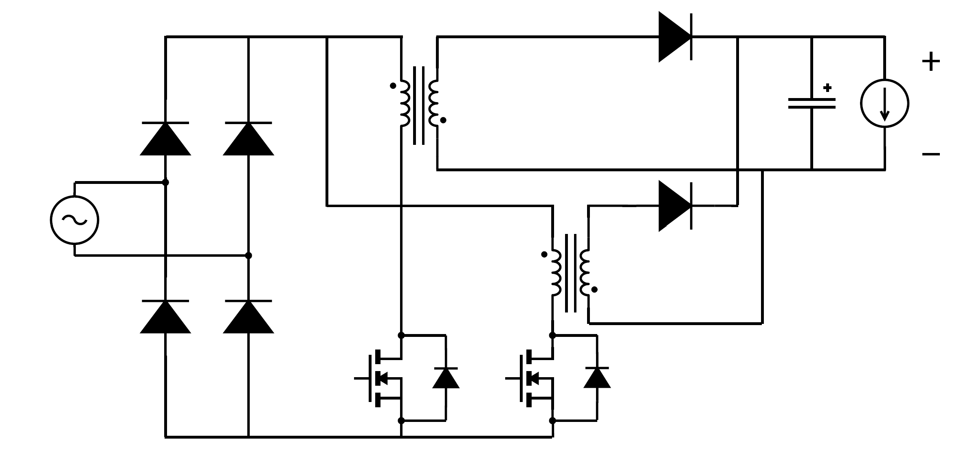  (c)  Fig. 1. Power supply configurations proposed for PD applications: (a) PFC boost, LLC, and buck converter combination in [10], [11], (b) PFC boost with AHB flyback [1], (c) two-phase interleaved flyback PFC rectifier. | 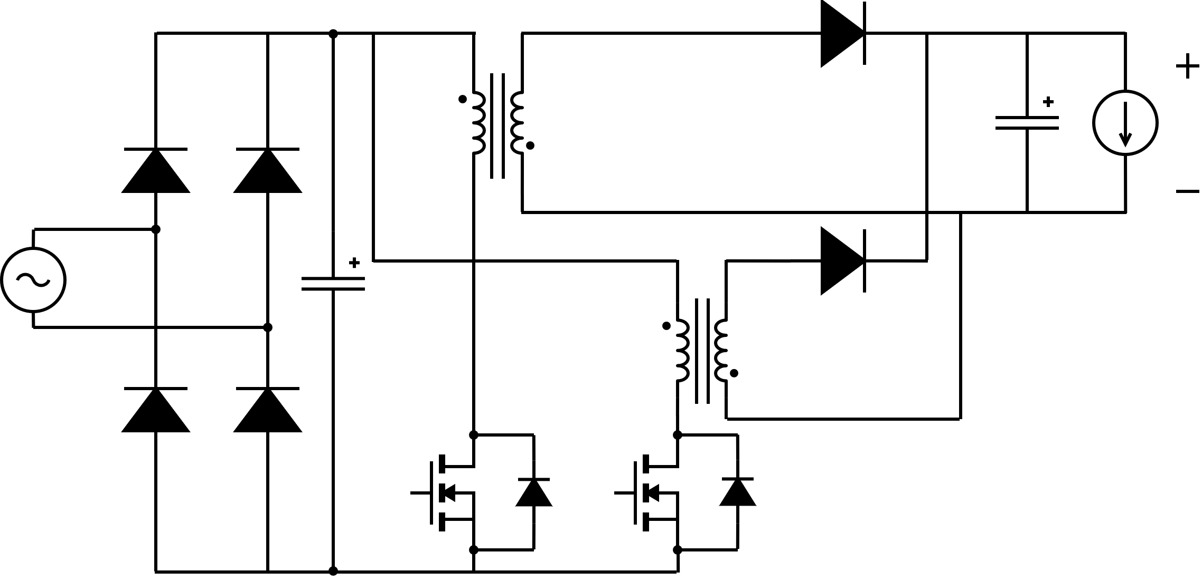  (c)  Fig. 1. Power supply configurations proposed for PD applications: (a) PFC boost, LLC, and buck converter combination in [10], [11], (b) PFC boost with AHB flyback [1], (c) two-phase interleaved flyback PFC rectifier.

2. Please explain how variations in input voltage affect the magnetic flux density and switch current stresses. A detailed theoretical analysis would improve understanding.
Thank you for this insightful comment. In the previous manuscript version, the equations detailing the magnetic flux density and switch current were presented primarily as static peak values for each active phase, as shown in Eq. (2) through (5). We completely agree that because this converter operates as a PFC rectifier, discussing the time-dependent behavior provides a much clearer understanding of the transient dynamics and the exact instantaneous component stresses.

To address this, we have expanded Section II-A to explicitly show the theoretical time-domain equations. Because the instantaneous input voltage follows a rectified, sinusoidal waveform, $v_{in}\left(t\right)=V_{in_{max}}|\sin\left(2πf_{line}t\right)|$. The exact instantaneous switch currents during their respective ON-intervals in a given switching cycle $k$, where $k=0,1,2,…$, can be expressed as:

For the first phase during the ON-time of $S_{1}$ ($kT_{s}≤t≤\left(k+D\right)T_{s}$):
$$i_{S_{1}}\left(t\right)=\frac{V_{in_{max}}|\sin\left(2πf_{line}t\right)|}{L_{m_{1}}}\left(t-kT_{s}\right) \left(2\right)$$

For the second phase during the ON-time of $S_{2}$, which is shifted by 180 degrees ($\left(k+0.5\right)T_{s}≤t≤\left(k+0.5+D\right)T_{s}$):
$$i_{S_{2}}\left(t\right)=\frac{V_{in_{max}}|\sin\left(2πf_{line}t\right)|}{L_{m_{2}}}\left(t-\left(k+0.5\right)T_{s}\right) \left(3\right)$$

By substituting these instantaneous currents into the flux density derivations, the exact transient magnetic flux densities for the outer legs $B_{o_{1}}^{'}\left(t\right)$ and the center leg $B_{c}^{''}\left(t\right)$ during their active intervals are:
$$B_{o}^{'}\left(t\right)=\frac{L_{m_{1}}i_{S_{1}}\left(t\right)}{N_{12}A_{o}} \left(4\right)$$

$$B_{o}^{''}\left(t\right)=B_{c}^{''}\left(t\right)=\frac{L_{m_{2}}i_{S_{2}}\left(t\right)}{N_{56}A_{c}} (5)$$
This theoretical analysis clearly demonstrates how the high-frequency switching ramps are continuously bounded by the rectified line cycle. Consequently, both the switch current and the core flux density vary dynamically, reaching their maximum values exactly at the peak of the AC line voltage, $V_{in_{max}}$.

Equations (2) to (5) in the manuscript have been revised to reflect these changes. We note that we examine the peak values of the switch current and flux density in the theoretical analysis provided in the manuscript, in a quasi-static switching event. We have added a dedicated paragraph detailing these exact operational dynamics, along with these expanded equations, to better clarify the transient behavior and component stress limits in the revised manuscript.
Before revision | After revision
(in Section II-A, at the operational mode analysis)  ….  The detailed analysis of each operating mode is as follows:  ….  2) Mode 2 ($t_{2}<t<t_{3}$, Fig. 3(b)): Mode 2 starts right after transformer $N_{56}-N_{78}$ completes its discharging phase, which means its associated currents $i_{D_{2}}$, $i_{L_{m_{2}}}$, and flux densities $B_{o_{1}}^{''}$, $B_{o_{2}}^{''}$, and $B_{c}^{''}$ are zero. Now, with $S_{1}$ still on, transformer $N_{12}-N_{34}$ continues storing energy until $i_{L_{m_{1}}}$ reaches its peak value at $t_{3}$. The peak primary current in the positive cycle $i_{S_{1_{pk}}}$ is given by (2):  $$i_{S_{1_{pk}}}=\frac{V_{in}⋅DT_{s}}{L_{m_{1}}}$$  where $V_{in}$ is the input voltage, $D$ is the duty cycle, $T_{s}$ is the switching period, and $L_{m_{1}}$ is the magnetizing inductance of transformer $N_{12}-N_{34}$. Consequently, the flux densities $B_{o_{1}}^{'}$ and $B_{o_{2}}^{'}$ also reach their peak values $B_{o_{pk}}^{'}$ which are given by (3):  $$B_{o_{pk}}^{'}=\frac{L_{m_{1}}i_{S_{1_{pk}}}}{N_{12}A_{o}}$$  with $N_{12}$ as the number of turns in the primary side of the active transformer and $A_{o}$ is the cross-sectional area of the outer leg, where the transformer $N_{12}-N_{34}$ is wound. | (in Section II-A, at the operational mode analysis)  ….  The detailed analysis of each operating mode is as follows:  ….  2) Mode 2 ($t_{2}<t<t_{3}$, Fig. 3(b)): Mode 2 starts right after transformer $N_{56}-N_{78}$ completes its discharging phase, which means its associated currents $i_{D_{2}}$, $i_{L_{m_{2}}}$, and flux densities $B_{o_{1}}^{''}$, $B_{o_{2}}^{''}$, and $B_{c}^{''}$ are zero. Now, with $S_{1}$ still on, transformer $N_{12}-N_{34}$ continues storing energy until $i_{L_{m_{1}}}$ reaches its peak value at $t_{3}$.  Because the converter operates as a PFC rectifier, the instantaneous input voltage follows a rectified sinusoidal envelope $v_{in}\left(t\right)=V_{in_{max}}|\sin\left(2πf_{line}t\right)|$, where $V_{in_{max}}$ is the peak AC line voltage and $f_{line}$ is the line frequency. Assuming $v_{in}\left(t\right)$ is quasi-static during a single high-frequency switching cycle, the time-variant peak primary current $i_{S_{1_{pk}}}\left(t\right)$ reached at the end of the ON-time of the first active phase is given by:  $$i_{S_{1_{pk}}}\left(t\right)=\frac{V_{in_{max}}|\sin\left(2πf_{line}t\right)|}{L_{m_{1}}}DT_{s} \left(2\right)$$  where $D$ is the duty cycle, $T_{s}$ is the switching period, and $L_{m_{1}}$ is the magnetizing inductance of transformer $N_{12}-N_{34}$. Consequently, the flux densities $B_{o_{1}}^{'}$ and $B_{o_{2}}^{'}$ also reach their cycle-specific peak values $B_{o_{pk}}^{'}\left(t\right)$ which are given by (3):  $$B_{o_{pk}}^{'}\left(t\right)=\frac{L_{m_{1}}i_{S_{1_{pk}}}\left(t\right)}{N_{12}A_{o}} \left(3\right)$$  with $N_{12}$ as the number of turns in the primary side of the active transformer and $A_{o}$ is the cross-sectional area of the outer leg, where the transformer $N_{12}-N_{34}$ is wound.
(in Section II-A, at the operational mode analysis)  ….  The detailed analysis of each operating mode is as follows:  ….  5) Mode 5 ($t_{5}<t<t_{6}$, Fig. 3(e)): Mode 5 starts after the discharge of transformer $N_{12}-N_{34}$ completes. Now, with Switch $S_{2}$ still on, transformer $N_{56}-N_{78}$ continues storing energy until $i_{L_{m_{2}}}$ reaches its peak value at $t_{6}$. The peak primary current in the negative cycle $i_{S_{2_{pk}}}$ is given by (4):  $$i_{S_{2_{pk}}}=\frac{V_{in}⋅DT_{s}}{L_{m_{2}}}$$  where $L_{m_{2}}$ is the magnetizing inductance of transformer $N_{56}-N_{78}$. Consequently, the flux densities $B_{o_{1}}^{''}$, $B_{c}^{''}$ and $B_{o_{2}}^{''}$ also reach their peak values. The peak value of $B_{c_{pk}}^{''}$ is given by (5):  $$B_{c_{pk}}^{''}=B_{o_{pk}}^{''}\left(t\right)=\frac{L_{m_{2}}i_{S_{2_{pk}}}}{N_{56}A_{c}}$$  with $N_{56}$ as the number of turns in the primary side of the active transformer and $A_{c}$ is the cross-sectional area of the center leg where the transformer $N_{56}-N_{78}$ is wound. | (in Section II-A, at the operational mode analysis)  ….  The detailed analysis of each operating mode is as follows:  ….  5) Mode 5 ($t_{5}<t<t_{6}$, Fig. 3(e)): Mode 5 starts after the discharge of transformer $N_{12}-N_{34}$ completes. Now, with Switch $S_{2}$ still on, transformer $N_{56}-N_{78}$ continues storing energy until $i_{L_{m_{2}}}$ reaches its peak value at $t_{6}$. Similarly bounded by the input voltage envelope, the time-variant peak primary current $i_{S_{2_{pk}}}\left(t\right)$ reached at the end of the ON-time of the second active phase is given by:  $$i_{S_{2_{pk}}}\left(t\right)=\frac{V_{in_{max}}|\sin\left(2πf_{line}t\right)|}{L_{m_{2}}}DT_{s} \left(4\right)$$  where $L_{m_{2}}$ is the magnetizing inductance of transformer $N_{56}-N_{78}$. Consequently, the flux densities $B_{o_{1}}^{''}$, $B_{c}^{''}$ and $B_{o_{2}}^{''}$ also reach their cycle-specific peak values. The time-variant peak value of the center leg flux density $B_{c_{pk}}^{''}\left(t\right)$ is given by (5):  $$B_{c_{pk}}^{''}\left(t\right)=B_{o_{pk}}^{''}\left(t\right)=\frac{L_{m_{2}}i_{S_{2_{pk}}}\left(t\right)}{N_{56}A_{c}} \left(5\right)$$  with $N_{56}$ as the number of turns in the primary side of the active transformer and $A_{c}$ is the cross-sectional area of the center leg where the transformer $N_{56}-N_{78}$ is wound.
N/A | (in Section II-A, inserted before the last paragraph)  As derived in the expanded time-variant equations for Mode 2 and Mode 5, the linear switching ramps are continuously bounded by the low-frequency cycle of $v_{in}$. Consequently, both the instantaneous switch current stress and the peak core flux density vary dynamically across the line period. The converter components experience their absolute maximum operational stresses exclusively at the peak of the AC line voltage $V_{in_{max}}.$

3. The duty cycle is not adequately defined in the manuscript.
Thank you for this valuable feedback. We agree that the definition of the duty cycle $D$ and its relationship to the discharge time $t_{dis}$, as given in Eq. (1), required further clarification.

First, we have revised the text to explicitly state that the proposed circuit relies on the exact same operating principles as a conventional two-phase interleaved flyback rectifier. The integration of the transformer does not alter the fundamental switching sequence or the definition of the duty cycle.

Because the converter must operate in Discontinuous Conduction Mode (DCM), the duty cycle $D$ strictly determines the ON-time of the switches. Consequently, it dictates how fast the stored energy in the magnetizing inductance discharges. As shown in Eq. (1), the discharge time $t_{dis}$ is simply the required interval for the magnetizing current of one phase to return to zero before the subsequent phase reaches its peak. We have updated Section II-A to make this operational equivalency and the boundaries of $D$ much clearer to the reader.

Furthermore, regarding the open-loop control scheme utilized in this study, the operating duty cycle is mathematically defined by the physical circuit specifications. We explicitly referenced Equation (28) in the manuscript, which defines $D$ as a function of the required output power $P_{o}$, switching period $T_{s}$, peak input voltage $V_{in_{max}}$, and magnetizing inductance $L_{m}$. This definition is completely consistent with standard conventional flyback design principles.

Before revision | After revision
(in Section II-A, 3rd paragraph)  The operational principle of the rectifier with the proposed transformer is illustrated in Fig. 3. Additionally, Fig. 4 presents the key waveforms of the six distinct operation modes. The rectifier is designed with duty cycle $D≤0.5\frac{nV_{o}}{V_{in_{max}}}$ with $n$ as the turns ratio, $V_{o}$ as the output voltage, and $V_{in_{max}}$ as the peak value of the input voltage. … | (in Section II-A, 3rd paragraph)  The operational principle of the rectifier with the proposed transformer is illustrated in Fig. 3. Additionally, Fig. 4 presents the key waveforms of the six distinct operation modes. It is important to note that despite the integrated magnetic structure, the rectifiers in each interleaved phase operate on the exact same principle as a conventional DCM flyback converter. The rectifier is designed with a strictly limited duty cycle $D≤0.5\frac{nV_{o}}{V_{in_{max}}}$ with $n$ as the turns ratio, $V_{o}$ as the output voltage, and $V_{in_{max}}$ as the peak value of the input voltage. …

4. How is power factor correction (PFC) achieved or ensured in the proposed converter? Please provide supporting analysis and experimental verification. The PFC control methodology is not clearly described.
Thank you for your valuable comment. The proposed two-phase interleaved flyback rectifier is designed to operate in Discontinuous Conduction Mode (DCM). A fundamental characteristic of a DCM flyback topology is that it naturally achieves power factor correction (PFC) without requiring a complex, active current-shaping control loop.

When the converter operates with a fixed switching frequency and a constant duty cycle $D$ across the AC line half-cycle, the peak and average currents drawn by each transformer phase during a switching period are directly proportional to the instantaneous rectified input voltage. Because there is no phase shift between the voltage and the drawn current, the total average input current inherently tracks the sinusoidal envelope of the AC input voltage, yielding a high-power factor under open-loop control.

The mathematical derivation confirming this inherent PFC behavior for the two-phase interleaved structure is detailed below:

Given a fixed switching frequency $f_{s}$ over the switching period $T_{s}$ and a constant duty cycle D across the AC line half-cycle, the peak current of the main switch for the first phase, $i_{S1_{pk}}\left(t\right)$, is determined by the instantaneous input voltage and is expressed as:
$$i_{S1_{pk}}\left(t\right)=\frac{v_{in}\left(t\right)DT_{s}}{L_{m}}$$
where $v_{in}\left(t\right)$ is the instantaneous rectified input voltage and $L_{m}$ is the magnetizing inductance of the active transformer phase.

The average input current drawn by the first phase over one switching period is calculated by integrating the triangular switch current waveform:

$$\left\langle i_{S1}\right\rangle \left(t\right)=\frac{1}{T_{s}}\int_{0}^{T_{s}}{i_{S1}}\left(τ\right)dτ=\frac{1}{T_{s}}\left(\frac{1}{2}i_{S1_{pk}}\left(t\right)DT_{s}\right)=\frac{v_{in}\left(t\right)D^{2}T_{s}}{2L_{m}}$$

Because the proposed converter utilizes a two-phase interleaved structure, the second phase operates identically to the first, shifted by 180 degrees. A symmetrical design is utilized in this flyback converter, where both phases share the same $L_{m}$, the average current drawn by the second phase is identical:

$$\left\langle i_{S2}\right\rangle \left(t\right)=\frac{v_{in}\left(t\right)D^{2}T_{s}}{2L_{m}}$$

The total average input current, $\left\langle i_{in}\right\rangle \left(t\right)$, drawn from the rectified input voltage is the sum of the average currents of both active phases:
$$\left\langle i_{in}\right\rangle \left(t\right)=\left\langle i_{S1}\right\rangle \left(t\right)+\left\langle i_{S2}\right\rangle \left(t\right)=\frac{v_{in}\left(t\right)D^{2}T_{s}}{L_{m}}$$
Since $D$, $T_{s}$, and $L_{m}$ are all constant values during steady-state open-loop operation, the total average input current is directly proportional to the instantaneous rectified input voltage:

$$\left\langle i_{in}\right\rangle \left(t\right)∝v_{in}\left(t\right)$$

Because $v_{in}\left(t\right)$ follows a rectified sinusoidal voltage $V_{in_{max}}|\sin\left(2πf_{line}t\right)|$), the input current inherently tracks the sinusoidal shape of the AC mains voltage. Consequently, the converter naturally achieves PFC in DCM without requiring a dedicated active current-shaping control loop. This is seen in the experimental waveform in Fig. 15(a), where we could see from the macroscopic view that $i_{S1}$ and $i_{S2}$ are in-phase with the AC input voltage $v_{in}$.

5. The experimental results are not sufficiently clear for readers to fully understand the converter operation. Consider improving waveform quality and adding more detailed explanations.
Thank you for your comments. We agree that the experimental waveforms needed improvement. We have revised the figures to have clearer traces by thinning the grid lines and making the colored traces more saturated. We also remove the cluttered annotations. The revised text for the explanation of the waveforms in Section V (Fig. 15) will be shown in the next comment, which also asks for a detailed explanation of the observed phenomena in the waveforms.

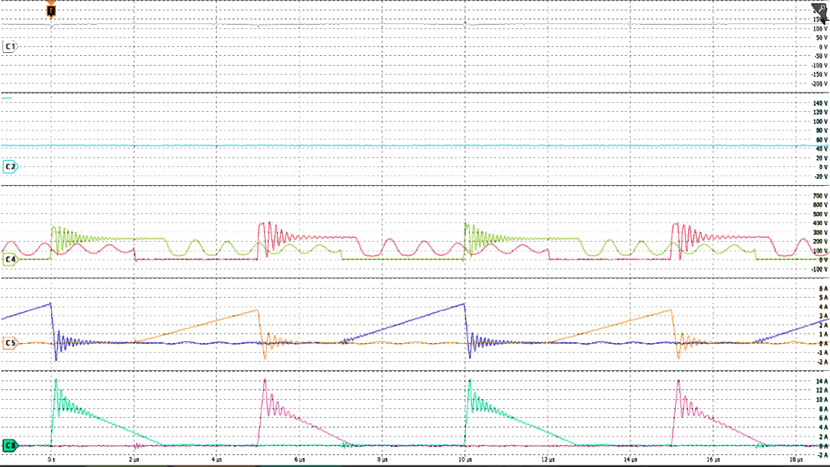
6. Significant ringing is observed during the switching transitions of S1 and S2. Please explain the cause of this oscillation and discuss possible mitigation methods.
7. A persistent oscillation is visible in the Vds1 waveform. Please provide a detailed explanation of its origin and impact on converter performance.
We thank the reviewer for these insightful comments. We address questions 6 and 7 together, as both pertain to parasitic resonant behaviors observed in the v_{ds} waveforms, though they are driven by two distinct mechanisms, as described in reference [26]. A sample waveform, shown in Fig. 15(c), is referenced in this discussion and is also placed below for easy reference. The annotations are removed as well for easier understanding.
Oscillations in the Switching Transitions of S₁ and S₂
The high-frequency ringing occurs immediately at turn-off and is caused by the resonance between the leakage inductance of the transformer $L_{lk}$ and the parasitic output capacitance $C_{oss}$ of the switches. This phenomenon occurs regardless of the conduction mode. To mitigate this voltage stress and absorb the leakage energy, snubbers are implemented across the primary windings, denoted as C_{sn}, R_{sn}, D_{sn} in Fig. 10(a).
Oscillations in v_{ds1} (and v_{ds2})
This lower-frequency oscillation happens when the secondary diode current i_{D1} and i_{D2} each reach zero. This signifies that the transformer fully demagnetizes. At this point, the main magnetizing inductance L_{m} begins to resonate with C_{oss}, causing the persistent oscillation until the next switching cycle initiates. We have thoroughly revised Section V-B of the manuscript to explicitly clarify these two distinct resonant mechanisms and referenced existing literature [26].

We fully agree with the reviewer that these resonant phenomena can introduce additional switching losses and potential reliability concerns if not properly mitigated. For this experimental prototype, we implemented a standard RCD snubber. While this basic snubber successfully dampens the transients enough to safely operate the converter and validate our proposed magnetic topology, we acknowledge that it is not the most optimal solution for maximizing overall efficiency.

However, deploying more complex mitigation strategies, such as active-clamping or advanced soft-switching techniques, falls outside the primary scope of this manuscript, which focuses strictly on proving the feasibility, volumetric reduction, and structural magnetic decoupling of the integrated transformer. Therefore, we deliberately utilized a standard RCD snubber to isolate and evaluate the performance of the magnetic structure itself, without the added complexity of advanced switching control.

The explanation of the waveforms in Section V are revised as follows taking into account the phenomena explained above.

8. A photograph of the hardware prototype would be helpful. Furthermore, if a comparison with existing solutions is claimed, the corresponding experimental setup and hardware implementation should be clearly presented.
Thank you for your comment. We have added a photograph of the hardware prototype in Figure xx, alongside a structural diagram to clearly identify the custom integrated transformer and main circuit components.

9. The manuscript should include a comprehensive comparison with relevant published literature to clearly demonstrate the advantages and unique contributions of the proposed approach.
Thank you for this valuable feedback. We completely agree that a direct, side-by-side comparison is necessary to clearly define the research gap and emphasize the distinct merits of our topology.

To address this, we have added a comprehensive comparative analysis in Section [X.X], supported by a newly introduced summary table (Table XX). This table benchmarks our proposed non-coupled integrated transformer against both conventional discrete magnetic solutions and recently published [insert specific topology, e.g., tightly-coupled / conventional integrated] methods.
Specifically, the expanded text and Table XX explicitly highlight the dual advantages of our approach:
- Core Volume Reduction: Demonstrating the physical miniaturization achieved compared to discrete implementations.
- Decoupled Transient Operation: Highlighting how our non-coupled integration uniquely achieves decoupled interleaved operation, avoiding the transient interference and cross-regulation issues often found in conventional integrated methods.
- Simpler Implementation: Decoupling can be implemented through a winding configuration with a simple EE-core.
We believe this direct comparison strictly quantifies our contributions and provides readers with a clear understanding of the proposed structure's advantages.

10. The explanation of the flux cancellation phenomenon is insufficient. Please provide a more rigorous theoretical analysis and supporting evidence. It would be beneficial to illustrate the magnetic flux path during each operating mode, all six modes as explained for working. Such diagrams would significantly improve clarity and reader understanding. (Why the flux in central limb is zero during mode1-3? It may zero for N12,34. Will there any flux present because of N56,78?)
Thank you for pointing out the need for deeper clarification. We can refer to Fig. 4 for the flux behavior.

To fully elucidate the magnetic decoupling and flux cancellation phenomenon, the magnetic flux waveforms in Fig. 4 can be referred to. During Modes 1, 2, and 3, only Phase 1 ($N_{12}-N_{34}$) is active.

The flux in the center leg during Modes 1-3 is indeed zero. During these modes, only the $N_{12}-N_{34}$ transformer is active. As shown in the equivalent magnetic circuit in Fig. 6(a), the fluxes generated by the two outer legs are equal in magnitude but opposite in direction through the center leg, causing perfect flux cancellation. Furthermore, during Modes 1-3, the $N_{56}-N_{78}$ transformer is entirely inactive (both primary and secondary currents are zero). Because no current flows through the $N_{56}-N_{78}$ windings, no magnetomotive force (MMF) is generated in the center leg. Central to this principle is the fact that two transformers are completely decoupled, causing no current to flow in the transformer of the inactive phase. We have revised the explanation of this principle more in Section II…

11. If, Mode1,2,3 are for +ve half cycle and mode 4,5, 6 are for negetive half cycle then can we represent the B01′ and B01′′ in the same time line graph??(Ref: Fig:4) Its difficult to understand.
Thank you for your comment. We apologize for the confusing terminology in the manuscript. The terms “positive” and “negative” cycle were chosen to describe the high-frequency interleaved switching phases, inadvertently implying AC line-frequency half-cycles. In reality, the two phases operate 180$°$ out of phase with the same T_{s}, meaning that they function in the same timeline.

The reason for separating the graphs in Fig. 4 is to merely denote which flux component, $B’$ or $B’’$, is generated by the active transformer in each respective phase. The fluxes contributed by the transformer active in Phase 1 ($N_{12}-N_{34}$) are denoted by $B'$, with the flux in the center, left, and right leg denoted as $B_{c}^{'}$, $B_{o1}^{'}$, or $B_{o2}^{'}$ respectively, before they are super-positioned in the core. The gate-source voltage, magnetizing current, switch current, and diode current during this phase are denoted as $v_{gs_{1}}$, $i_{L_{m_{1}}}$, $i_{S_{1}}$ and $i_{D_{1}}$. Similarly, the relevant quantities contributed by the transformer active in Phase 2 ($N_{56}-N_{78}$) are denoted by ${B'}_{c}^{'}$, ${B'}_{o1}^{'}$, or ${B'}_{o2}^{'}$ for the fluxes, and $v_{gs_{2}}$, $i_{L_{m_{2}}}$, $i_{S_{2}}$ and $i_{D_{2}}$ for the voltages and currents. We have rigorously revised the terminology in Section II, replacing "positive/negative AC input" with "Phase 1 active period" and "Phase 2 active period," and added a clarifying note to Fig. 4 to explain the timeline mapping.

Before revision | After revision
(3rd paragraph of section II)  The operational principle of the rectifier with the proposed transformer is illustrated in Fig. 3. Additionally, Fig. 4 presents the key waveforms of the six distinct operation modes….. | (3rd paragraph of section II)  The operational principle of the rectifier with the proposed transformer is illustrated in Fig. 3. Additionally, Fig. 4 presents the key waveforms of the six distinct operation modes. The operation modes are examined under six-time intervals relative to the switching period of S₁. …
(4th paragraph of section II)  To describe the magnetic state of the core, the superposition principle is used, as shown in Fig. 5(a). The magnetic flux density component B’ is generated by the positive cycle transformer defined as N₁₂ −N₃₄. The magnetic flux density component B’’ represents the component generated by the negative cycle transformer defined as N₅₆ −N₇₈. The total flux in any leg is the algebraic sum of these components. This superposition determines the peak flux density required for the core design, which is analyzed in detail in Section II-B. | (4th paragraph of section II)  To describe the magnetic state of the core, the superposition principle is used, as shown in Fig. 5(a). The magnetic flux density component B’ is generated by the transformer active in the first phase defined as N₁₂ −N₃₄. The magnetic flux density component B’’ represents the component generated by the transformer active in the second phase defined as N₅₆ −N₇₈. The total flux in any leg is the algebraic sum of these components. This superposition determines the peak flux density required for the core design, which is analyzed, which is analyzed in detail in Section II-B.
(5th paragraph of section II)  Modes 1, 2, and 3 in Figs. 3(a)-(c) cover the operation during the positive AC input into the rectifier, while Modes 4, 5, and 6 in Figs. 3(d)-(f) describe the operation during the negative AC input. For the following modes, B’_{o1}, B’_{o2}, and B’_{c} represent the magnetic flux densities in the respective left, right, and center legs of the core caused by the transformer active in positive AC input N₁₂−N₃₄, respectively, which are shown in Fig. 5(b). On the other hand, B’’_{o1}, B’’_{o2}, and B’’_{c} represent the magnetic flux densities in the respective left, right, and center legs of the core caused by the transformer active in negative AC input N₅₆ − N₇₈, respectively, which are detailed visually in Fig. 5(c). | (5th paragraph of section II)  Modes 1, 2, and 3 in Figs. 3(a)-(c) cover the operation during the first active phase, while Modes 4, 5, and 6 in Figs. 3(d)-(f) describe the operation during the second active phase. The six modes are examined under the switching period T_{s} of S₁. For the following modes, B’_{o1}, B’_{o2}, and B’_{c} represent the magnetic flux densities in the respective left, right, and center legs of the core caused by N₁₂−N₃₄, respectively, which are shown in Fig. 5(b). On the other hand, B’’_{o1}, B’’_{o2}, and B’’_{c} represent the magnetic flux densities in the respective left, right, and center legs of the core caused by N₅₆−N₇₈, respectively, which are detailed visually in Fig. 5(c).
(in Section II-A, at the operational mode analysis)  …The peak primary current in the positive cycle $i_{S_{1_{pk}}}$ is given by (2)...  …The peak primary current in the negative cycle $i_{S_{2_{pk}}}$ is given by (4)... | (in Section II-A, at the operational mode analysis)  …the time-variant peak primary current $i_{S_{2_{pk}}}\left(t\right)$ reached at the end of the ON-time of the second active phase is given by (2):  …the time-variant peak primary current $i_{S_{2_{pk}}}\left(t\right)$ reached at the end of the ON-time of the second active phase is given by (4):
(Caption of Fig. 4)  Fig. 4. Key waveforms in the operation of the two-phase interleaved flyback rectifier with the proposed transformer, with $D≤0.5\frac{nV_{O}}{V_{in_{max}}}$. | (Caption of Fig. 4)  Fig. 4. Key waveforms in the operation of the two-phase interleaved flyback rectifier with the proposed transformer, with $D≤0.5\frac{nV_{O}}{V_{in_{max}}}$. S₁ and S₂ operate 180$°$ out of phase and have the same $T_{s}$. The flux densities $B^{'}$ and $B^{''}$ represent the individual, un-superimposed magnetic flux components generated in the first and second active phase by $N_{12}-N_{34}$ and $N_{56}-N_{78}$ respectively.

12. Some portions of the manuscript appear repetitive. The presentation could be improved by consolidating overlapping discussions and avoiding redundancy.
Thank you for the comments. Various figures and

13. Please provide a more detailed explanation of the mechanism by which the proposed topology improves light-load efficiency. Quantitative results would strengthen the discussion.
Thank you for your comment. In some coupled flyback topologies that cannot operate independently, utilizing phase-shedding at light loads induces voltages across the inactive phase, generating circulating currents that severely degrade light-load efficiency. Because our proposed integrated transformer inherently features zero magnetic coupling between phases, the active phase causes no magnetic interference in the inactive phase. Thus, the converter can seamlessly deactivate one phase at light loads without suffering from induced circulating currents. Therefore, we believe that our topology can contribute to improved light-load efficiency by providing a way for decoupling the two phases.

While we agree that quantitative results would further strengthen this discussion, an exhaustive evaluation of light-load efficiency falls outside the primary scope of this research. The experimental prototype developed for this study was specifically designed to validate the proposed magnetic integration. Consequently, precise quantitative measurements isolating the efficiency improvements during light-load phase-shedding were not captured. We have, however, clarified the theoretical explanation of this decoupling mechanism in the revised manuscript and noted the quantitative optimization of light-load operation as an area for future work.

Before revision | After revision
(5th paragraph of section I)  ...In single-phase operation, when the phases are highly coupled, the active phase inevitably induces a voltage across the inactive phase, generating circulating currents that reduce light-load efficiency [17], [18]. | (5th paragraph of section I)  When mutual coupling exists between windings, the phases influence one another. In some coupled flyback topologies that cannot operate independently, utilizing phase-shedding for single-phase operation at light loads induces a voltage across the inactive phase. This generates circulating currents that degrade light-load efficiency [17], [18].
(1st paragraph of Section VI)  ...The structure is estimated to enable up to a 56% downsizing of magnetic components compared to conventional discrete transformers. | (1st paragraph of Section VI)  ...The structure is estimated to enable up to a 56% downsizing of magnetic components compared to conventional discrete transformers. While this study primarily validates the magnetic integration and heavy-load performance, the quantitative evaluation and optimization of light-load efficiency during phase-shedding remain an area for future work.

14. Strengthen the litreture survey and refrences.
Thank you very much for your comment. Please see the response to Question 9.

To Reviewer 3
We authors appreciate your valuable comments. The revised parts are indicated by red texts in the manuscript.
Comments to the Author
This paper analyzes the design and implementation of an interleaved Flyback converter based on magnetic integration. My comments are as follows:
(1) The efficiency of the converter is a very important indicator. The paper should include the efficiency curve of the converter, as well as the efficiency comparison with the interleaved Flyback converter without magnetic integration, and also the efficiency comparison analysis with other similar converters.
We thank you for the comment of highlighting the importance of the efficiency metrics. We agree that evaluating it is indeed crucial for validating the proposed integrated magnetic structure.

Regarding the direct experimental efficiency comparison with a conventional interleaved flyback utilizing discrete transformers, we respectfully note that a purely experimental comparison was not performed. Because the proposed topology operates identically to a conventional discrete implementation and achieves near-perfect decoupling ($k≈0.0005$), the semiconductor and switching losses are expected to remain nearly identical. Therefore, the efficiency differences lie strictly within the magnetic components. To provide a rigorous comparison, we have instead added a detailed analytical loss breakdown of the transformer structures to the revised manuscript. This analysis demonstrates how the 56% reduction in core volume lowers baseline core losses, and how distributing the asymmetric turns (24:8 and 18:6) across the outer and center legs mitigates $R_{dc}$ and heavily suppresses $R_{ac}$ proximity effects.

In response to your suggestion, we have included the experimental efficiency curve of the proposed integrated converter across the operating load range in the revised manuscript, demonstrating a peak efficiency of 84.6% near full load. The revised portion is as shown below.

Finally, regarding the comparison with other similar converters, because experimental efficiencies across different literature prototypes are heavily influenced by the specific selection of semiconductor devices, the control method, and snubber optimizations, we cannot make a fair comparison. Our comparison instead focuses on the decoupling methods implemented compared to other solutions. focuses primarily on the fundamental structural advantages of our approach: the significant improvement in magnetic power density (56% core volume reduction) and the validation of magnetic decoupling within a single EE-core without circulating currents.

(2) The modulation results of the interleaved converter are not mentioned in the paper, especially the experimental results.
Thank you for your comments. The experimental tests for this prototype were performed using open-loop control (fixed duty cycle) to strictly isolate and verify the fundamental magnetic decoupling of the proposed transformer structure. Because the focus of this paper is the magnetic component itself, with the fundamental electrical operation of the flyback unchanged from the conventional setup, standard closed-loop modulation and control schemes can be directly applied without modification. Therefore, we did not include specific closed-loop modulation results. We have added a clarifying note in section xx of the manuscript to better explain the scope of our experimental verification.

(3) The volume advantage brought by magnetic integration needs to be further explained, and the benefits brought by magnetic integration should be explained by comparison.
Thank you for your comments. We found an advantage in terms of core losses. Please see the response to Reviewer #1 (Comment #6)

(4) As a PFC, more experimental waveforms need to be provided, including the operating condition where the power factor is not 1, the dynamic waveform of the output voltage, etc.
Thank you for your comments. However, as this two-phase Interleaved Flyback PFC operates in DCM, then PFC occurs naturally. We have shown the derivation in the comment by Reviewer 2 (Comment # 4).

(5) Photos of the experimental prototype need to be shown in the paper.
Thank you for your comments. The experimental prototype is shown in Figure xx. Please see the comment from Reviewer 1 (Comment #5) for more details.
- End of the response letter-

